Weekend Highlights
- Hearing from God – As Christians we are called first and foremost to listen to the voice of God and then obey it. Yet, surprisingly, most Christians say they have never heard from God. You will receive basic skills to hear from God at the Friday night session!

- Healing from God - Some Christians say that God doesn’t heal miraculously at all today. Other say its God’s will to heal you the way you think He should. The truth is in-between these two opposing positions. You will learn about healing prayer ministry at the Saturday sessions.

- Saturday Night Healing Service – 7:30 pm – You will experience God’s healing power in your life!
For the kingdom of God is not a matter of talk but of power.
1 Corinthians 4:20

Schedule

June 1st Friday Night Teaching
6:30-6:45 Gathering Worship
6:45-8:15 Hearing God’s Voice
8:15-8:30 Break
8:30-9:30 Experiencing the Presence and the Love of God

June 2nd Saturday Teaching
9:00-9:15 Gathering Worship
9:15-9:45 Seasons of the Lord
- what God has done and is doing again.
9:45-10:30 What is healing?
10:30-10:45 Break
10:45-12:00 Biblical principle of our authority in praying for physical healing: James 4
12:00-1:00 Lunch Provided
1:00-1:15 Gathering Worship
1:15-3:15 Prayer Ministry:
Following the pattern of Jesus in Luke 9:11:
3:15-3:30 Break
3:30-4:00 Praying for one another in small groups
4:00-5:30 Preparation to minister
5:30-7:30 Dinner Provided
7:30-9:00 Healing Service

About our Speakers
Kathy Hershman - For the past six years, Kathy has served as the Director of The Prayer Center in Princeton, Kentucky. Here they have seen many miraculous healings along with many other signs, wonders, and miracles. Kathy is dedicated to teaching others how to minister the love and healing available through Jesus Christ to a lost and broken world.
Don Hershman - Don is a worshipper, worship leader, and prophetic psalmist-songwriter. Having been radically saved in 1997, Don has a great passion for the presence, fire, and glory of God. His primary assignment in the body of Christ is to lead others to extravagantly worship God in spirit and truth. He is anointed to impart a passion for God through worship, as well as teach on practical aspects prophetic worship and
prophesying in song.

Mail Registration to:
Tabor UMC
P.O. Box 38
Woxall, PA 18979
Name: _______________
Street: _______________
City: _______________
State/Zip _______________
Phone _______________
# Adults (18+) ____ # Youth (12 - 17) ____ # Children (4 – 11) ____
Cost:
$10 per Adult
$5 per Youth (12 to 17). Youth are free if accompanied by at least one parent.
Children 11 and Under are Free
Nursery for Birth – 3. Child care provided for Children ages 4 to 11.
Deadline for Registration is May 15, 2012.
Scholarships Available. Call: 215 234 4852

About Tabor UMC
Tabor United Methodist Church is a growing family of faith connecting with the communities of the Indian and Perkiomen Valleys with love and developing mature disciples of Jesus Christ.
We commit ourselves to the life-changing teachings and example of Jesus every day and encourage one another through prayer and service.

We are located at 2209 Hendricks Station Road, Woxall, PA 18979
Web address: taborumc.org
Call us at 215-234-4852 for any questions.
Fax us at 215-234-8255
Church Office Hours - Monday – Friday, 8pm to 1pm
Call the church for housing questions. Hotels are located near PA Turnpike near Lansdale (#31) and Quakertown (#44) exits

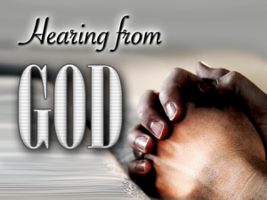
Hearing from God
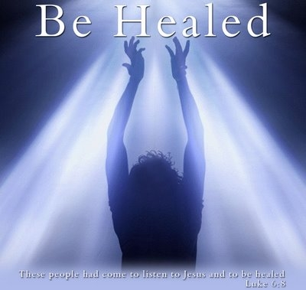
Healing from God
With Don and Kathy Hershman
Friday June 1st and Saturday June 2nd
Tabor United Methodist Church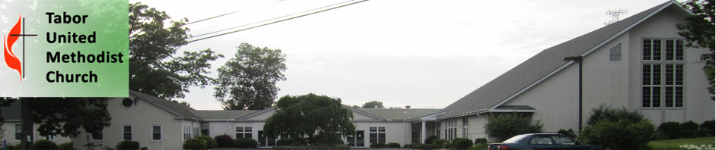
Honoring God, Serving Others and Making Disciples Daily

